The Second Coming of Christ – Pt. 1
Biblical Reasons for His Return
Ken Birks, Pastor/Teacher

I. Introductory Remarks.

The Second Coming of the Lord Jesus Christ is the hope of the church. This is the event that we as Christians all look forward to. The Second Coming of Jesus gives us a vivid expectation of grand and glorious things taking place at His appearing. It also gives us a faith picture of being changed and conformed into His image, being totally delivered and freed from the bondage of this flesh. It also gives us the faith picture of living and reigning with God throughout eternity.

- Without the hope of the 2nd Coming, we are in a perpetual state of pity.

1 Corinthians 15:19-23 If in this life only we have hope in Christ, we are of all men the most pitiable. ²⁰ But now Christ is risen from the dead, and has become the firstfruits of those who have fallen asleep. ²¹ For since by man came death, by Man also came the resurrection of the dead. ²² For as in Adam all die, even so in Christ all shall be made alive. ²³ But each one in his own order: Christ the firstfruits, afterward those who are Christ's at His coming.

- We shall all be changed in the twinkling of an eye.

1 Corinthians 15:51-54 Behold, I tell you a mystery: We shall not all sleep, but we shall all be changed; ⁵² in a moment, in the twinkling of an eye, at the last trumpet. For the trumpet will sound, and the dead will be raised incorruptible, and we shall be changed. ⁵³ For this corruptible must put on incorruption, and this mortal must put on immortality. ⁵⁴ So when this corruptible has put on incorruption, and this mortal has put on immortality, then shall be brought to pass the saying that is written: "Death is swallowed up in victory."

II. Biblical Reasons For The Second Coming of Christ.

There are a number of reasons as to why it is absolutely essential that Jesus comes again and that He comes in bodily form of which we will look at in this section of the study.

1. If He Doesn’t Come, There Can Be No Resurrection of the Dead.

It is at the Second Coming of Christ that the dead in Christ are raised, which means If Christ does not come they will not rise from the dead.

1 Thessalonians 4:16-17 For the Lord Himself will descend from heaven with a shout, with the voice of an archangel, and with the trumpet of God. And the dead in Christ will rise first. ¹⁷Then we who are alive and remain shall be caught up together with them in the clouds to meet the Lord in the air. And thus we shall always be with the Lord.

2. We Need to See Him In Order to Be Changed Into His Image.

1 John 3:2-3 Beloved, now we are children of God; and it has not yet been revealed what we shall be, but we know that when He is revealed, we shall be like Him, for we shall see Him as He is. ³ And everyone who has this hope in Him purifies himself, just as He is pure.

3. When He Comes, We Will Dwell with Him Forever.

Jesus has promised us that He is preparing a special place for each one of us where we will dwell with Him forever and ever.

John 14:1-3 "Let not your heart be troubled; you believe in God, believe also in Me. ² "In My Father's house are many mansions; if it were not so, I would have told you. I go to prepare a place for you. ³ "And if I go and prepare a place for you, I will come again and receive you to Myself; that where I am, there you may be also.

4. God’s Word Must Be Fulfilled.

God’s word must be fulfilled in every manner and that includes the promises He made concerning His Second Coming. All that the prophets have said concerning His coming must come to pass.

Ezekiel 12:25-28 "For I am the LORD. I speak, and the word which I speak will come to pass; it will no more be postponed; for in your days, O rebellious house, I will say the word and perform it," says the Lord GOD.'" ²⁶ Again the word of the LORD came to me, saying, ²⁷ "Son of man, look, the house of Israel is saying, 'The vision that he sees is for many days from now, and he prophesies of times far off.' ²⁸ "Therefore say to them, 'Thus says the Lord GOD: "None of My words will be postponed any more, but the word which I speak will be done," says the Lord GOD.'"

Acts 1:9-11 Now when He had spoken these things, while they watched, He was taken up, and a cloud received Him out of their sight. 10 And while they looked steadfastly toward heaven as He went up, behold, two men stood by them in white apparel, 11 who also said, "Men of Galilee, why do you stand gazing up into heaven? This same Jesus, who was taken up from you into heaven, will so come in like manner as you saw Him go into heaven."

Jesus will be sent by the Father in due time, when everything that the prophets have spoken has been fulfilled. Until then, the heavens must retain Him.

Acts 3:19-21 "Repent therefore and be converted, that your sins may be blotted out, so that times of refreshing may come from the presence of the Lord, ²⁰ "and that He may send Jesus Christ, who was preached to you before, ²¹ "whom heaven must receive until the times of restoration of all things, which God has spoken by the mouth of all His holy prophets since the world began.

5. Just Judgment Must Be Brought Upon The Ungodly.

When Jesus returns He will also execute judgment upon all that is ungodly with Satan thrown into the pit and bound for a 1000 years.

Jude 1:14-15 Now Enoch, the seventh from Adam, prophesied about these men also, saying, "Behold, the Lord comes with ten thousands of His saints, ¹⁵ "to execute judgment on all, to convict all who are ungodly among them of all their ungodly deeds which they have committed in an ungodly way, and of all the harsh things which ungodly sinners have spoken against Him."

2 Thessalonians 1:6-10 since it is a righteous thing with God to repay with tribulation those who trouble you, ⁷ and to give you who are troubled rest with us when the Lord Jesus is revealed from heaven with His mighty angels, 8 in flaming fire taking vengeance on those who do not know God, and on those who do not obey the gospel of our Lord Jesus Christ. ⁹ These shall be punished with everlasting destruction from the presence of the Lord and from the glory of His power, ¹⁰ when He comes, in that Day, to be glorified in His saints and to be admired among all those who believe, because our testimony among you was believed.

6. He is Coming To Gather In The Harvest.

Revelation 14:14-16 Then I looked, and behold, a white cloud, and on the cloud sat One like the Son of Man, having on His head a golden crown, and in His hand a sharp sickle. ¹⁵ And another angel came out of the temple, crying with a loud voice to Him who sat on the cloud, "Thrust in Your sickle and reap, for the time has come for You to reap, for the harvest of the earth is ripe." ¹⁶ So He who sat on the cloud thrust in His sickle on the earth, and the earth was reaped.

James 5:7 Therefore be patient, brethren, until the coming of the Lord. See how the farmer waits for the precious fruit of the earth, waiting patiently for it until it receives the early and latter rain.

7. He is Going To Show All Creation That He Is The King of Kings and Lord of Lords.

1 Timothy 6:14-16 that you keep this commandment without spot, blameless until our Lord Jesus Christ's appearing, ¹⁵ which He will manifest in His own time, He who is the blessed and only Potentate, the King of kings and Lord of lords, ¹⁶ who alone has immortality, dwelling in unapproachable light, whom no man has seen or can see, to whom be honor and everlasting power. Amen.

Revelation 19:11-16 Now I saw heaven opened, and behold, a white horse. And He who sat on him was called Faithful and True, and in righteousness He judges and makes war. ¹² His eyes were like a flame of fire, and on His head were many crowns. He had a name written that no one knew except Himself. ¹³ He was clothed with a robe dipped in blood, and His name is called The Word of God. ¹⁴ And the armies in heaven, clothed in fine linen, white and clean, followed Him on white horses. ¹⁵ Now out of His mouth goes a sharp sword, that with it He should strike the nations. And He Himself will rule them with a rod of iron. He Himself treads the winepress of the fierceness and wrath of Almighty God. ¹⁶ And He has on His robe and on His thigh a name written: KING OF KINGS AND LORD OF LORDS.

8. He Comes To Put Down and Destroy All Unrighteousness, Sin, and Every Antichristial Force.

2 Thessalonians 2:7-10 For the mystery of lawlessness is already at work; only He who now restrains will do so until He is taken out of the way. ⁸ And then the lawless one will be revealed, whom the Lord will consume with the breath of His mouth and destroy with the brightness of His coming. ⁹ The coming of the lawless one is according to the working of Satan, with all power, signs, and lying wonders, 10and with all unrighteous deception among those who perish, because they did not receive the love of the truth, that they might be saved.

9. He Will Come to Establish His Kingdom on Earth.
Revelation 20:6 Blessed and holy is he who has part in the first resurrection. Over such the second death has no power, but they shall be priests of God and of Christ, and shall reign with Him a thousand years.

II. Concluding Remarks.

As you can see, there are many reasons for Jesus's return. We have been commissioned by Jesus to occupy until He comes. Even though we are to await His return anxiously, we must continually press into the things of the kingdom and work with Him while He builds His Church and establishes His kingdom on earth as it is in heaven, against which the gates of Hell will not prevail.

For a complete study on this subject and much more, please see the book listed below:

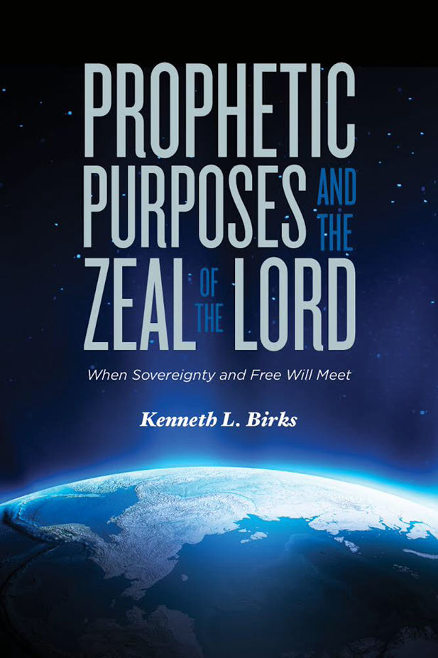
Aside from complete teaching on the Second Coming of Christ and the Great Tribulation, the essence of this book considers that God has sovereign purposes in the earth that He will yet fulfill through His sovereignty. Amid performing them, He uses imperfect vessels like you and me to do so. How does our free will work together with God’s sovereignty to bring forth His purposes as He fulfills them from one generation to another? This book explores these questions and much more. We discover that one of the Father’s most significant traits—His patience, combined with our obedience - allows us to be involved with Him.

For more information and how to order the book, click the link below:

Predestinated Purposes Sovereignty and Free Will

For all of the Six Lessons, Click Here

