The Dynamics of Biblical Change

Facilitator Instructions: The words in italic are possible answers you are looking for as you lead the discussion. Give a number of people time to answer the questions before you try to answer the question. Also, always have group members look up the Scriptures in their Bibles while one group member reads.

As you lead the discussion, be open to the Holy Spirit and what He is doing during the meeting. You may never get beyond one or two questions if they are provoking a great discussion. It may also be that someone in the group needs important ministry because of what the discussion opened in their heart. Take the time to allow the Holy Spirit to minister the person through your group members.

Ice Breaker: What brought about one of the greatest changes in your life or a recent change?"

Bible Study Discussion: The Dynamics of Biblical Change

The Christian life is a life of transformation and change.

2 Corinthians 3:18 But we all, with unveiled face, beholding as in a mirror the glory of the Lord, are being transformed into the same image from glory to glory, just as by the Spirit of the Lord.

Facilitator: Make sure that you have made copies of this diagram and have passed them out before asking the question.

- When you look at the illustration below, at what level do you see yourself?
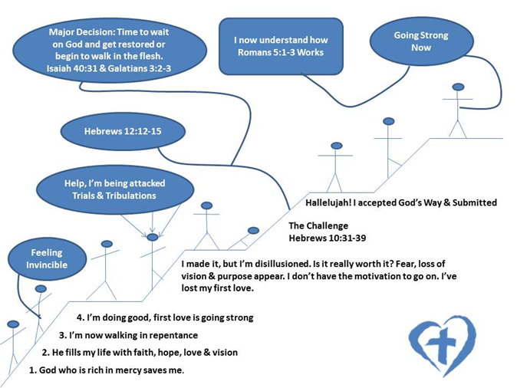

- For those of you who are on level three, share a testimony of how God was able to help you after being disillusioned or losing your vision and purpose.

- What would be your encouragement to someone who is stuck on level two?

Facilitator: Share the thought below and then ask the questions.

The Christian life is not static: It is a life of change. Each stage of our walk with God involves us with constant moving change, precept upon precept, line upon line, here a little, there a little.

- What are a couple of the biggest changes you have had to go through as a Christian?

- When you think about change, “how does God initiate change in your life?”

Facilitator: Share the following and then ask the question below. Share the answer that’s in italic only after your group members have attempted to answer the question.

His will is progressive by nature meaning we must constantly adapt to changes in our lives where the will of God is leading us.

- What do you think are the primary reasons Christians sometimes fail to respond to change?

Many Christians fail to respond to change as God directs because of two primary reasons: 1) They lack the motivation to change, 2) they desire to, but they are not quite sure how to appropriate the changes.

Facilitator: Have someone read the Scripture below and then ask the question below that goes with it.

Ephesians 4:1-3 I, therefore, the prisoner of the Lord, beseech you to walk worthy of the calling with which you were called, ²with all lowliness and gentleness, with longsuffering, bearing with one another in love, ³endeavoring to keep the unity of the Spirit in the bond of peace.

- What are some motivational keys that help us to change?

Facilitator: After your group has shared their answers share #’s 1&2 with them.

- Our Desire to Change Is Something That Pleases the Lord.

In our desire to have a walk that is worthy of our calling we see in the passage above that we are to walk in lowliness and gentleness, with longsuffering, bearing with one another etc.

To have a walk that encompasses these attitudes involves submitting ourselves to the changing process that God has ordained for our lives.

- Change Brings Forth a Greater Measure of Our Spiritual Inheritance.

Since change is an act of obedience, we reap blessing upon blessing when we respond to God in obedience.

1 John 3:22 And whatever we ask we receive from Him, because we keep His commandments and do those things that are pleasing in His sight.
Having a heart to change as God directs us to, helps to maintain His joy and peace in our lives.

Romans 14:17 for the kingdom of God is not eating and drinking, but righteous-ness and peace and joy in the Holy Spirit.

Facilitator: Share #3 below, ask the question, then give group members time to answer before sharing the five symptoms that represent change.

- What do you think are some symptoms that represent a need for change in our lives?

3. Learn to Recognize the Symptoms that Represent a Need for Change.

- Having a feeling of being unsatisfied
- Having a feeling of being resisted.
- Having a feeling of uselessness.
- Having a feeling of lacking
- Having a feeling of being out of date with the move of God.

If you have any one of these feelings, it's probably a good indication that you have a need for Biblical change in your life; because the Christian life is not static, it is a life of change.

Prayer & Discovery

- For those who are stuck on level two, how can we pray for you?
- What area in your life do you sense God’s conviction to change?

Facilitator: Make several copies of the next page so that each person in your group has a copy of the diagram.

